UI wireframe of BioMentor AI Web App
This wireframe shows the four main screens:
- Login Screen → simple sign-in form with options to register or reset password.
- Dashboard → highlights knowledge gaps, quick stats, and buttons to start lessons or quizzes.
- Learning Chat → interactive Q&A with diagrams, quizzes, and a text input for student questions.
- Progress Tracker → mastery chart, weak areas list, and personalized study recommendations.
Together, these screens illustrate how students would move seamlessly from logging in → exploring content → interacting with the AI tutor → tracking their progress.
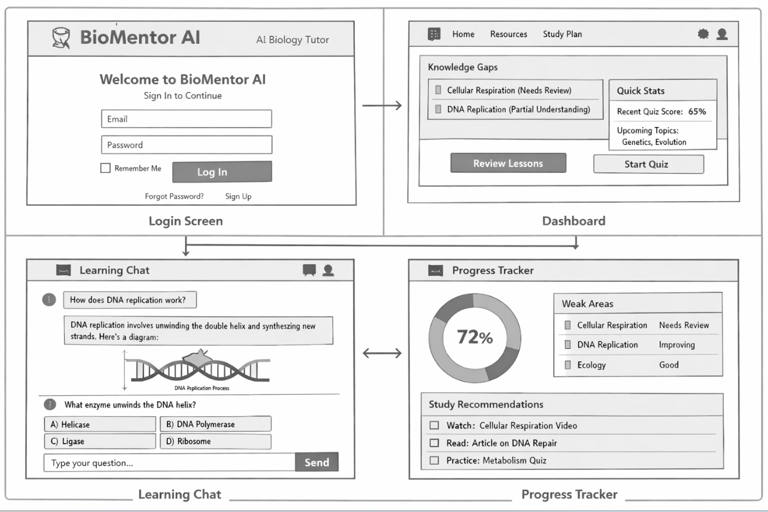
Storyboard: Student Navigation Flow
This diagram shows the student’s navigation journey step by step:
- Login → student enters credentials and signs in.
- Dashboard → reviews knowledge gaps and clicks Review Lessons.
- Learning Chat → interacts with AI tutor, answers quizzes, and receives feedback.
- Progress Tracker → checks mastery level and study recommendations.
- Updated Dashboard → sees improved scores and new suggested topics.
Arrows connect each stage, including conditional paths for correct or incorrect answers, showing how the AI adapts dynamically.
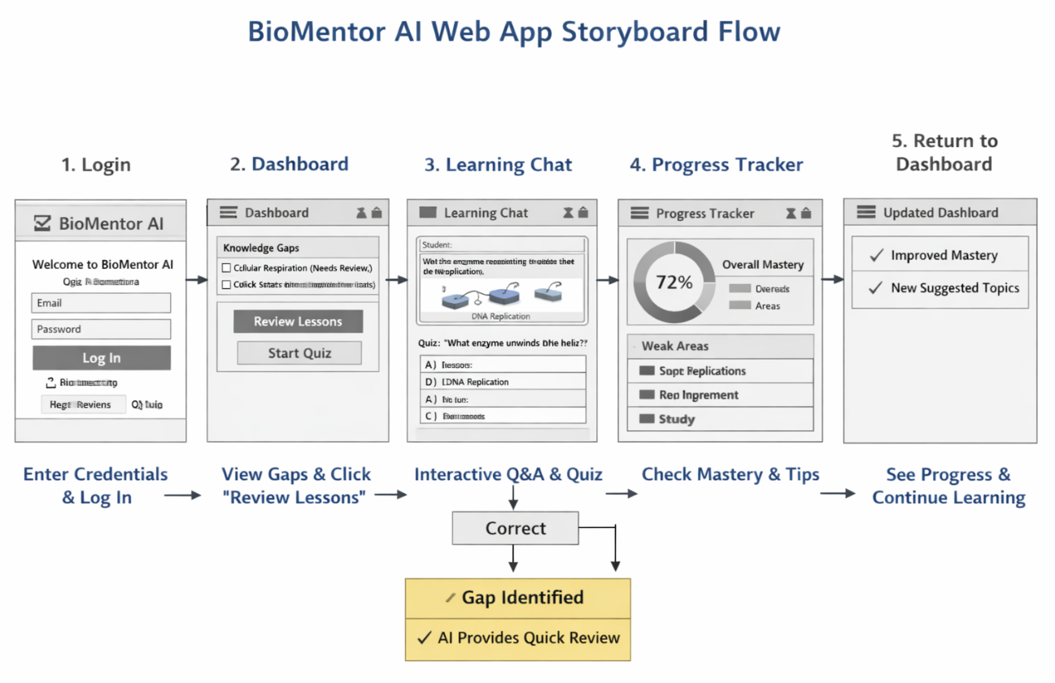
Teacher/Admin Dashboard Flow
This diagram shows how educators interact with the system and how AI supports their decisions across five stages:
- Educator Login → access class overview and alerts for struggling students.
- Class Dashboard → view average mastery and click into individual student analytics.
- Student Analytics → inspect mastery charts, gap alerts, and assign reinforcement lessons.
- Class Insights → analyse topic-level trends and schedule group reviews.
- Communication Hub & Admin Analytics → send personalized messages and monitor institutional performance.
Arrows connect each stage, illustrating how teachers move from overview to intervention and feedback, with AI assisting at every decision point.
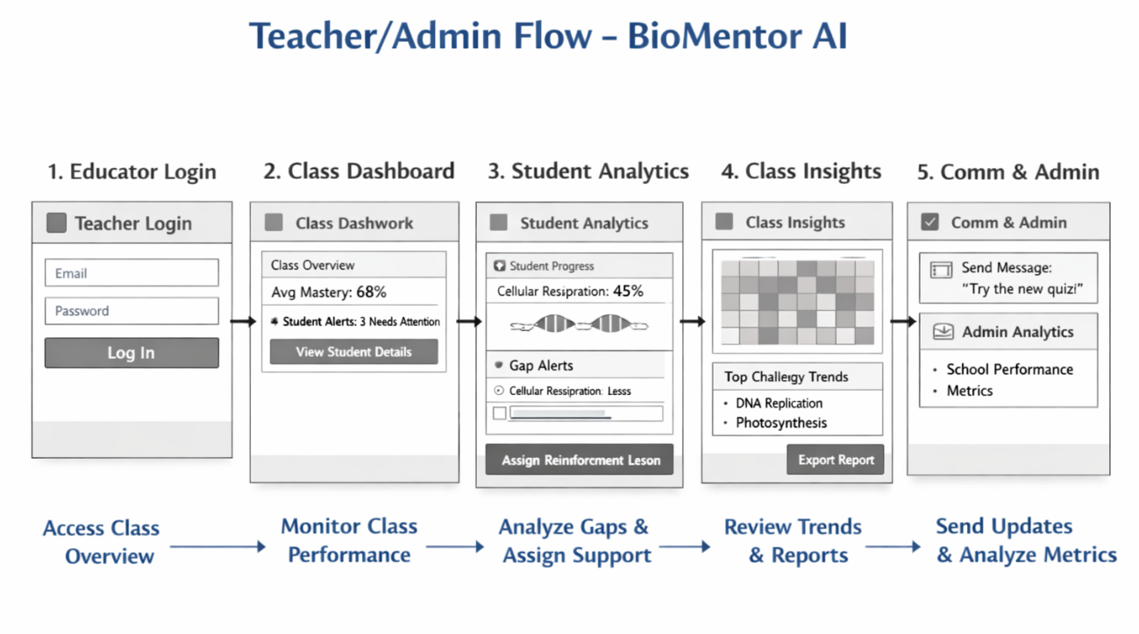
Shared collaboration flow diagram
This diagram shows how teachers and students interact in real time through the AI Collaboration Hub:
- Teacher Interface → launches live sessions and shares resources.
- Student Interface → joins sessions, asks questions, and participates in polls or quizzes.
- AI Collaboration Hub → mediates discussion, retrieves accurate biology content via RAG, and identifies shared learning gaps.
- Real-Time Analytics → tracks engagement, quiz results, and concept mastery.
- Post-Session Summary → provides insights, suggested practice, and follow-up tasks for both teacher and students.
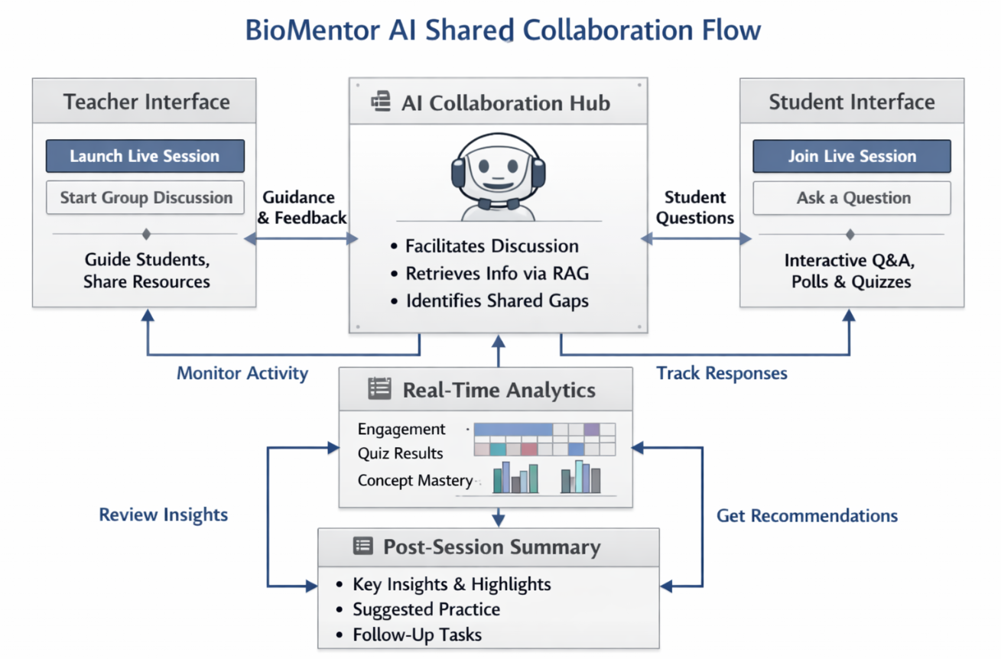

Web App Architecture for BioMentor AI
1. Frontend (Student Interface)
- Frameworks: React, Angular, or Vue for dynamic UI.
- Features:
  - Chat window for Q&A with the AI tutor.
  - Interactive diagrams and quizzes.
  - Dashboard showing knowledge gaps and progress.
  - Resource library with videos, articles, and simulations.
2. Backend (AI + RAG + Gap Detection)
- Agentic AI Core:
  - Orchestrates tutoring flow, decides when to quiz, explain, or suggest resources.
  - Built on an LLM with reasoning capabilities.
- RAG Pipeline:
  - Connects to biology knowledge sources (textbooks, PubMed, educational APIs).
  - Embedding + vector database (e.g., Pinecone, Weaviate, FAISS) for retrieval.
- Gap Detection Engine:
  - Tracks student answers and interaction logs.
  - Uses analytics + ML models to detect weak areas.
  - Maps gaps to curriculum standards.
3. Database Layer
- Student Profiles: Stores progress, quiz results, and personalized study plans.
- Content Repository: Indexed biology materials for retrieval.
- Gap Analytics: Records detected weaknesses and improvement over time.
4. Deployment
- Cloud Hosting: Azure, AWS, or GCP for scalability.
- Authentication: Secure login for students and teachers.
- Integration: Option to connect with LMS (Moodle, Canvas, Google Classroom).
5. Example Student Flow in Web App
- Student logs in → sees dashboard with current knowledge gaps.
- Asks a question → AI retrieves accurate biology content via RAG.
- AI quizzes student → gap detection engine flags weak areas.
- Dashboard updates → suggests targeted resources and practice.
Smart learning assistant (web app ) or any recommendation RAG +LLM +USING ECOSYSTEM for preparation for exams
•⁠ ⁠advanced agentic AI workflows for generating answers to questions(give me the suggestions how to make it in innovative way and with lesser cost)
•⁠ ⁠Offline access for the PDF uploaded, user-friendly
•⁠ ⁠Basic quiz categorisation aligned to Bloom’s Taxonomy
•⁠ ⁠Lightweight visual support from uploaded material
•⁠ ⁠There should be minimal uploading of data in GB or any recommendations accepted for lesser data uploading
•⁠ ⁠Future-scale architecture beyond minimal preparation( accepting your recommendation or alternative)
•⁠ ⁠Source references
•⁠ ⁠Upload and delete documents
•⁠ ⁠Data protection and security
•⁠ ⁠Registration of the application

